**Computer Networks**

**Problem-solving session 9-2**

**Build a Switch and Router Network**

**Topology**

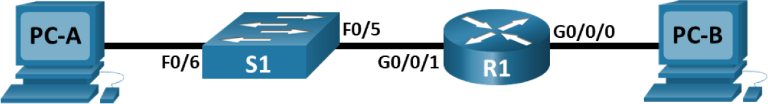

**Addressing Table**

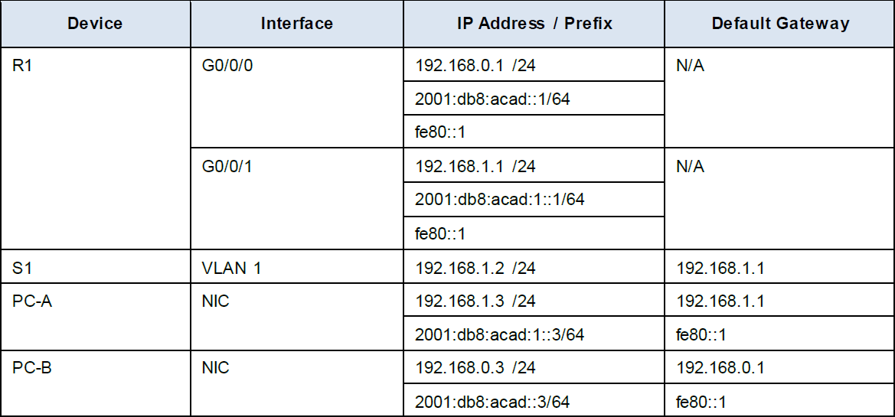

**Objectives**

**Part 1:** Set Up the Topology and Initialize Devices

**Part 2:** Configure Devices and Verify Connectivity

**Background / Scenario**

This is a comprehensive lab to review IOS commands. In this lab, you will cable the equipment as shown in the topology diagram. You will then configure the devices to match the addressing table. After the configurations have been saved, you will verify your configurations by testing for network connectivity.

This lab provides minimal assistance with the actual commands necessary to configure the router. Test your knowledge by trying to configure the devices without referring to the content or previous activities.

**Note:** The routers used with CCNA hands-on labs are Cisco 4321. The switches used in the labs are Cisco Catalyst 2960. Other routers and switches can be used. Depending on the model and Cisco IOS version, the commands available and the output produced might vary from what is shown in the labs.

**Note:** Ensure that the routers and switches have been erased and have no startup configurations. Consult with your instructor for the procedure to initialize and reload a router and switch.

**Part 1: Set Up Topology and Initialize Devices**

**Step 1**: Cable the network as shown in the topology.

a. Attach the devices shown in the topology diagram, and cable, as necessary.

b. Power on all the devices in the topology.

**Step 2**: Initialize and reload the router and switch.

If configuration files were previously saved on the router and switch, initialize and reload these devices back to their default configurations.

**Part 2: Configure Devices and Verify Connectivity**

In Part 2, you will set up the network topology and configure basic settings, such as the interface IP addresses, device access, and passwords.

**Step 1**: Assign static IP information to the PC interfaces.

a. Configure the IP address, subnet mask, and default gateway settings on PC-A.

b. Configure the IP address, subnet mask, and default gateway settings on PC-B.

c. Ping PC-B from a command prompt window on PC-A.

**Note:** If pings are not successful, the Windows Firewall may need to be turned off.

Why were the pings not successful?

____________________________________________________________________________

**Step 2**: Configure the router.

a. Console into the router and enable privileged EXEC mode.

b. Enter configuration mode.

c. Assign a device name to the router.

d. Disable DNS lookup to prevent the router from attempting to translate incorrectly entered commands as though they were host names.

e. Assign **class** as the privileged EXEC encrypted password.

f. Assign **cisco** as the console password and enable login.

g. Assign **cisco** as the VTY password and enable login.

h. Encrypt the plaintext passwords.

i. Create a banner that warns anyone accessing the device that unauthorized access is prohibited.

j. Configure and activate both interfaces on the router.

k. Configure an interface description for each interface indicating which device is connected to it.

l. To enable IPv6 routing, enter the command **ipv6 unicast-routing**.

R1(config)# ipv6 unicast-routing

m. Save the running configuration to the startup configuration file.

n. Set the clock on the router.

**Note**: Use the question mark (?) to help with the correct sequence of parameters needed to execute this command.

o. Ping PC-B from a command prompt window on PC-A.

**Note**: If pings are not successful, the Windows Firewall may need to be turned off.

Were the pings successful? Explain.

____________________________________________________________________________

**Step 3**: Configure the switch.

In this step, you will configure the hostname, the VLAN 1 interface and its default gateway.

a. Console into the switch and enable privileged EXEC mode.

b. Enter configuration mode.

c. Assign a device name S1 to the switch.

d. Disable DNS lookup to prevent the router from attempting to translate incorrectly entered commands as though they were host names.

e. Configure and activate the VLAN interface on the switch S1.

f. Configure the default gateway for the switch S1.

g. Save the running configuration to the startup configuration file.

**Step 4**: Verify connectivity end-to-end connectivity.

a. From PC-A, ping PC-B.

b. From S1, ping PC-B.

**All the pings should be successful.**